Kindergarten Class Shirt Order Form
Due Friday, September 22
(Will be needed multiples times throughout the school year)
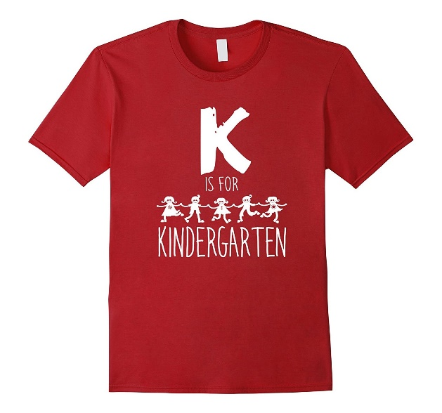

Student’s Name _____________________________________________________________

Teacher’s Name _____________________________________________________________

Youth Sizes:
Extra- Small (4-5) _____ Small (6-8) _____ Medium (10-12) _____ Large (14-16) _____

Adult Sizes:
Small_______ Medium_______ Large_______ Extra Large_____ 2XL_____

Number of shirts (XS-XL) ___________ X $6.00 = ________________

2XL Number of shirts___________ X $8.00 = ________________

Total Amount Enclosed $____________________________

